SBA-10

211505-SUNITHA VN

1. Write a Binary search program to search the elements of the integer Array.

**import** java.util.*;

**public** **class** Binarysearch {

**static** **int** binarySearch(**int** a[], **int** beg, **int** end, **int** val)

{

**int** mid;

**if**(end >= beg)

{

mid = (beg + end)/2;

**if**(a[mid] == val)

{

**return** mid+1;

}

**else** **if**(a[mid] < val)

{

**return** *binarySearch*(a, mid+1, end, val);

}

**else**

{

**return** *binarySearch*(a, beg, mid-1, val);

}

}

**return** -1;

}

**public** **static** **void** main(String args[]) {

Scanner sc=**new** Scanner (System.***in***);

System.***out***.println("Enter the Array Size");

**int** size=sc.nextInt();

**int**[] arr=**new** **int**[size];

System.***out***.println("Enter the elements for the sorted array:");

**for**(**int** i=0;i<size;i++)

{

arr[i]=sc.nextInt();

}

System.***out***.println("Enter the Elements to be Searched:");

**int** item=sc.nextInt();

System.***out***.println();

**int** result= *binarySearch*(arr,0,size-1,item);

**if** (result==-1)

{

System.***out***.println("Element" +item+ "is not present in the given array");

}

**else**

{

System.***out***.println("Element " +item+ " is present at position " +result+ " in the given array");

}

sc.close();

}

}

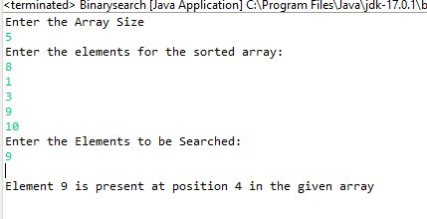

1. Create a login page using the Bootstrap and also include the Typescript and ES6 features like Loops, If-else conditions.

